Name: Samarth A

Reg No: 2347251

Class: MCA - B

Domain: Hospital Management System

**Entities:**

1. Hospital
2. Patient
3. Doctor
4. Nurse
5. Staff
6. Department
7. Ward/Room
8. Medication
9. Appointment
10. Billing
11. Test

**Attributes and Data Types:**

Hospital

1. Hospital ID (Integer): A unique identifier for each hospital
2. Hospital Name (String): The name of the hospital
3. Address (String): The address of the hospital
4. Contact Number (String): The main contact number of the hospital
5. Email (Integer/String): The email address of the hospital
6. License Number (Integer): The license number of the Hospital

Patient:

1. Patient ID(Integer): A unique identifier for each patient
2. Patient Name (String): Name of the patient
3. Date Of Birth (Date): The date of birth of the patient
4. Gender (String): The of the patient
5. Contact Number (Integer): The contact number of the patient
6. Address (String/Text): The address of the patient residence
7. Blood Group (String): The blood group of the patient
8. Medical History (String); A summary of the patients medical history and about his previous conditions on health
9. Emergency Contact (Integer/String): The name and contact information of a person to be contacted in case of any emergencies
10. Insurance Information (String): Details of the patients health insurance

Doctor:

1. Doctor ID(Integer): A unique identifier for each doctor
2. Doctor Name (String): Name of the doctor
3. Date of Birth (Date): The date of Birth of the doctor
4. Gender (String): The gender of the doctor
5. Contact Number (Integer): The contact number of the doctor
6. Email (String/Integer): Email ID of the doctor
7. Specialization (String): The medical specialization of the doctor in which he/she is expertise
8. Qualification (String); The professional qualification of the doctor
9. Years of Experience (Integer): The number of years the doctor has in their field
10. Availability (String): Information about the doctors availability, such as working hours or schedule for the day.
11. License Number (Integer): License Number of the doctor
12. Address (String): residence address of the doctor

Nurse

1. Nurse ID(Integer): A unique identifier for each nurse
2. Nurse Name (String): Name of the nurse
3. Date of Birth (Date): The date of Birth of the nurse
4. Gender (String): The gender of the nurse
5. Contact Number (Integer): The contact number of the nurse
6. Email (String/Integer): Email ID of the nurse
7. Shift (String): information about the nurse working shift
8. Qualification (String); The professional qualification of the nurse
9. Years of Experience (Integer): The number of years the nurse has in their field
10. Department (String): The department to which the nurse is assigned
11. License Number (Integer): The license number the nurse
12. Address (String): residence address of the nurse

Staff

1. Staff ID (Integer): A unique identifier for each staff member
2. Name (String): Name of the staff member
3. Date of Birth (date): The date of birth of the staff member
4. Gender (String): The gender staff member
5. Contact Number (Integer): The contact number of the staff member
6. Email (String/Integer): Email ID of the nurse
7. Role (String): The role or the position of the staff member in the hospital
8. Department (String): The department to which the staff member belongs in hospital
9. Qualification (String); The professional qualification of the staff member
10. Employment Status (String): Information about the staff member employment status
11. Joining Date (Date): The date when staff member will start his/her job in hospital
12. Address (String): residence address of the staff member

Department

1. Department ID (Integer): A unique identifier for each department
2. Department Name (String): The name of the department
3. Description (String): A brief description of the departments function
4. Head of Department (String): The name of the doctor or staff member who heads the department
5. Contact Number (Integer): The contact number of the department or head of department
6. Location (String): The location or ward number where department is situated in the hospital
7. Capacity (Integer): The maximum number of patients or beds the department can accommodate or handle
8. Facilities (String); A specific facilities or equipment available in the department (e.g., MRI, X-ray, Scanning)
9. Availability (String): About department timings and schedule
10. Services (String): The medical services or treatments offered by the department

Ward/Room

1. Ward/Room Number (Integer/String): A unique identifier for each ward or room in the hospital
2. Type (String): The type or category of the ward/room
3. Capacity (Integer): The maximum number of patients the ward/room can accommodate
4. Occupancy (Integer): The current number of patients admitted to the ward/room.
5. Availability (String): Information about the availability status of the ward/room(e.g., vacant, occupied)
6. Floor (Integer): The floor or level where the ward/room is located in the hospital
7. Special Facilities (String): Any special type of room/ward or equipment available in the ward
8. Nurse in Charge (String): The name of the nurse or staff member responsible for the ward/room.
9. Doctor Name (String): The name of the doctor to whom the patients are assigned in room/ward
10. Billing Information (String/Integer): Information related to billing and cost associated with the ward/room
11. Patients List (String): The list of patients name who got admitted to the room/ward
12. Admit Date (Date): The date of patients who is going to admit in that particular room/ward
13. Discharge Date (Date): The date of patients who is going to discharge from that particular room/ward
14. Maintenance Schedule (Date): The date where that particular room/ward assigned to main the facilities that include in that room/ward

Medication

1. Medication ID (Integer/String): A unique identifier for each medication record
2. Medication Name (String): The name of the medication
3. Doctor ID (Integer): The doctor who have prescribed the medication
4. Patient ID (Integer): The patient who is buying the medication
5. Dosage (String/Integer): The prescribed dosage or strength of the medication
6. Frequency (String): How often the medication should be taken by patient
7. Instructions (String): Any specific instructions or precautions related to taking the medication
8. Quantity Available (Integer): The current quantity available of medication
9. Cost (Integer): The cost of the medication
10. Manufacturer (String): The name of the pharmaceutical company for the medication
11. Expiry Date (Date): The date until which the medication is considered safe and effective
12. Batch Number (Integer): The batch to which the medication is belong to
13. Supplier Information (String): It contains the information of supplier for the particular medication

Appointment

1. Appointment ID (Integer): A unique identifier for each appointment record
2. Patient ID (Integer): The unique identifier of the patient who scheduled the appointment
3. Doctor ID (Integer): The unique identifier of the doctor with whom the appointment is scheduled
4. Date (Date): The date on which the appointment is scheduled
5. Time (Time): The specific time slot or time of day for the appointment
6. Reason (String): The reason or the purpose of the appointment
7. Status (String): The status of the appointment like e.g., scheduled, completed, canceled , rescheduled etc.,
8. Duration (Time): The expected duration/time or length of the appointment
9. Location (String): The location where the appointment will take place
10. Payment Information (String): The information about payment to the appointment

Billing

1. Billing ID (String): A unique identifier for billing record
2. Patient ID (String): The Unique identifier of the patient for whom the billing is generated
3. Doctor ID (String): The unique identifier of the doctor who provided the medical services for the patient
4. Date (Date): The date on which the billing was generated
5. Total Cost (Integer): The total cost of medical services or treatments provided to the patient.
6. Payment Status (String): The status of the payment for the billing like e.g., paid, pending, overdue
7. Payment Method (String): The method used fir payment like e.g., cash, credit card, insurance
8. Invoice Number (Integer): The unique number for the billing receipt
9. Discount (Integer): Any applicable discount applied to the total cost

Test

1. Test ID (Integer): A unique identifier for each test record
2. Test Name (String): The name of the test
3. Description (String): A brief description of the test and its purpose
4. Patient ID (Integer): The unique identifier of the patient for whom the test is being conducted
5. Doctor ID (Integer): The unique identifier of the doctor who ordered the diagnostic test
6. Date (Date): The date on which the test is scheduled or performed
7. Result (String/Integer): The result or the outcome of the test
8. Status (String): The status of the test
9. Cost (Integer): The cost of the test
10. Lab Technician Name(String): The name of the lab technician or staff member who will conduct the test for patient

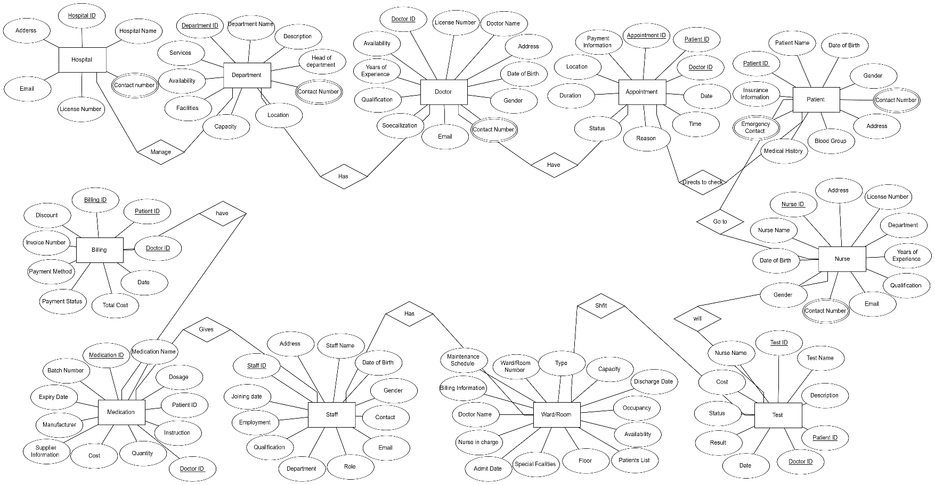**ER – DIAGRAM**

`